Monkstown Nursery School
Parent Information Booklet

Welcome to
Monkstown Nursery School

Supportive Happy Inclusive Nurturing Empowering

Jennings Park, Monkstown
Newtownabbey
BT37 0NB
Tel 028 90861459

Monkstown Nursery School is a controlled school, maintained by the Education Authority, North Eastern Division.

We cater for 78 children of pre-school age, with one full-time and two part-time sessions. Monkstown Nursery is a very happy place, where all children are valued, respected and encouraged to develop life skills and a love of learning.

In Monkstown Nursery School, we consider the uniqueness of each child as the basis for our provision. Sensitive, caring professionals provide a Supportive, Happy, Inclusive, Nurturing and Empowering learning environment and plan relevant, challenging experiences for every child.

We aim to be:-
- Supportive to children, parents, staff and the wider school community as we work together to achieve improved outcomes for our children.
- A Happy place to play, learn, work and visit. We want children to enjoy being children and to have fun, as we encourage them to follow their own interests.
- Inclusive to every child and family, as we endeavour to reduce the barriers to learning and promote an inclusive environment, providing equality of opportunity.
- Nurturing towards all, as we ensure the safeguarding, care and well-
- being of the children underpins all aspects of the curriculum. We regard personal, social and emotional development as the foundation for all areas of learning.
- Empowering, as we provide opportunities for children to feel confident to try new challenges and make informed choices and decisions that will promote their wellbeing.
With parents as partners, we aim to enable all children to develop to their full potential, as they grow in confidence, independence and compassion.

In Monkstown Nursery we believe: -

- Every child is a unique individual with his/her own needs
- Learning for young children is holistic and not separated into subjects
- Children learn through first hand experiences, using their senses to develop an understanding of their world. Staff should build on each child’s natural curiosity and desire to experiment
- Play is central to a child’s learning process; play is the business of childhood
- What children can do rather than what they cannot do is the starting point in their education
- Young children require opportunities to experience success and develop a positive attitude towards learning
- Children need to feel confident to try out new ideas or take on new challenges in a climate where they are not afraid to make a mistake or get something wrong.

At Monkstown Nursery we:
- Allow children to learn at their own pace;
- Help children to gain a positive image of themselves as learners;
- Enable children to: -
  - be able to cope with uncertainty
  - learn through trial and error
  - build upon the learning that has taken place in the home and its immediate environment.

The Curriculum

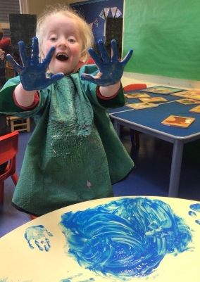
Monkstown Nursery follows the DENI curriculum guidance for Pre-School education which is set out under six headings:

- Personal Social and Emotional Development;
- Physical Development and Movement;
- Language and Literacy Development;
- Early Mathematical Experiences;
- The Arts;
- The World Around Us.

Through planning, sensitive support and involvement, careful observation and record keeping, we aim to provide a rich variety of stimulating play experiences, where the children are challenged and their learning is extended in all areas of their development.

As the revised preschool Curricular Guidance states:-

“As all children are different and develop at different rates, pre-school education aims to develop the whole child by:
- promoting emotional, social, physical, creative and intellectual development;
- developing self-esteem, self-control and positive attitudes towards others;
- developing language and communication skills to encourage the sharing of thoughts and feelings; and
- creating confident, eager, enthusiastic, independent, curious learners with a positive and problem-solving attitude to learning.”

Self-Selection

In our Nursery School we want our children to be as independent and self-reliant as possible. For this reason, we are very keen that the children make their own decisions about what they would like to play with. A range of equipment/resources is always available to the children so that they may select and make independent choices.

We believe it is important the children also have responsibility for taking care of our resources. At the end of each session in Nursery School tidy up time plays an important part in our day with all the children working together with the staff to reset the classroom for the next session.
Starting Monkstown Nursery School

Here are some suggestions to help prepare your child before coming to school:

- Talk to your child about going to school and how exciting it will be. Talk about the nursery staff and the different areas of the nursery, i.e. playroom, quiet room, toilet area, outdoor area etc. You can use your nursery leaflet to help familiarise your child with the setting and staff;

- Talk about your child staying in school without you;

- Allow your child to have opportunities for messy play, i.e. water, sand, dough and paint;

- Read lots of stories and sing nursery rhymes with your child;

- Create opportunities for your child to mix with other children and adults;

- Go over our Sunshine Rules with your child (page 16) and use some of the positive language at home;

- Encourage your child to “help” at home and to become independent in certain tasks, e.g. using the toilet independently, handwashing, eating independently and tidying up toys independently;

- Fill in your special book with your child.

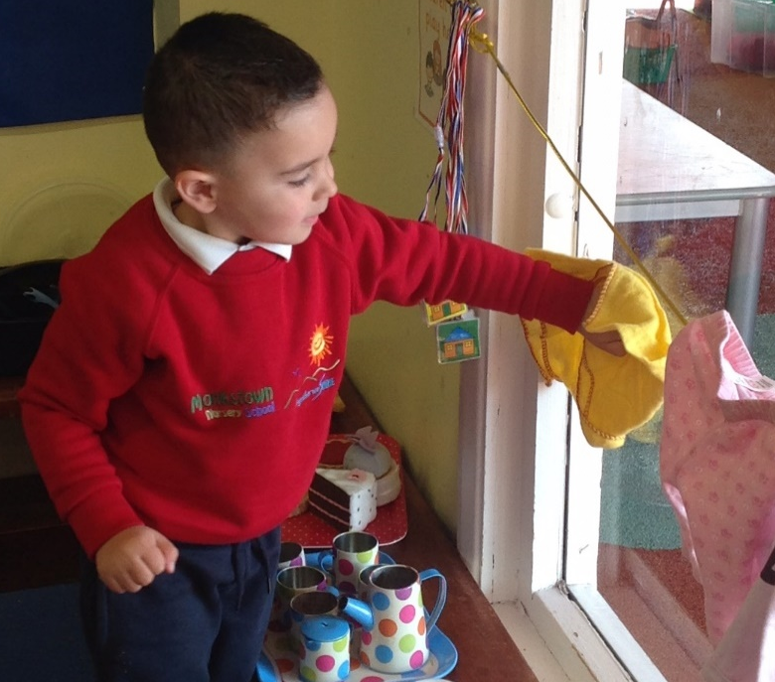

Settling into Nursery

We regard you, our parents, as partners and your interest, support and co-operation are very important to life in the nursery, particularly as you have been your child’s first and foremost educator. We hope you will support your child, realising the benefits of early years’ education and extend the school experiences at home.
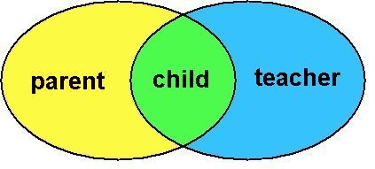

This is a very new experience for your child and for you. We aim to work along with you to ensure that your year at nursery will be a positive and happy experience.

Stage 1

A short visit will be arranged in June for you and your child to become familiar with the nursery environment.

Stage 2

Starting nursery- Children will attend in small groups of 13 for one hour. (Following our parental discussion some children including those with a statement of educational needs will be brought in prior to this.)

- This benefits your child as during the settling in period we aim to get to know the children very well and help them quickly get used to the rules and routines of nursery. This will work best when there are only a small number of children present.
- The children will be able to form relationships and gain confidence in themselves and their surroundings in a less intimidating setting.

Stage 3

As the weeks progress, the time your child spends in the nursery will be increased until your child is staying for the full session.

As your child becomes familiar with the new surroundings and gets to know the other children and the staff, he/she will have the opportunity to become more confident and at home. The staff will observe your child closely and if we feel he/she is having any difficulty settling we will discuss this with you. Also, if you feel your child is having difficulty settling in then please let us know. You will receive a settling in timetable during your August induction visit.

Important points

- If both parents are working, please ensure that an adult with whom the child feels totally secure (e.g. grandparent, childminder etc.) is available for the child’s settling in period.

- It is important that other siblings are not present during this period. As your child settles into school, we want to give him/her our full attention.

- Remember each child is different. Try not to compare them with others. Some may take a few days - others may take longer.

- If your child is upset or distressed, we will comfort them and ensure that we fully support their emotional wellbeing.

Parental Partnership
You are placing your child into the trust of qualified staff who are always willing to discuss any of your child’s issues in a confidential manner and at an appropriate time. Your support as parents is essential in working with the school for your child’s benefit. The school encourages parental participation in various ways such as out of school educational trips, invitations to meetings with teachers, and other events.
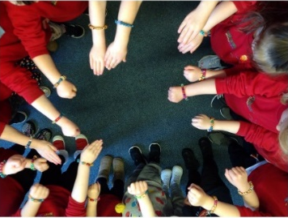
We had introduced a parent and friends’ group to provide vital practical and financial support to the school and we would encourage you to invest in this group. We are hoping to restart our Friends’ of Monkstown Nursery School group as we know by working together we will strive to provide the best quality of education for your child.
Nursery Arrival Procedures

At Monkstown we will continue to adopt a staggered arrival time with the morning class commencing at 8.45am, the full time at 9.00am and the afternoon session at 12.30pm.

- The full time class will enter through the metal gate which is at the far end of the building. The part time classes will enter via the foyer.
- A member of staff will meet each child at their entrance point.
- We would encourage a swift hand over.
- If your child is upset or distressed, we will work with you on an individual basis.

The doors to the nursery will be locked 10 minutes after each session has started.

If you are late, please ring the buzzer at the left hand side of the doors. Please do try to arrive within the flexible time.

Leaving your child into nursery can be a very emotional time for both the adult and child. We fully understand this and will do everything we can to facilitate a smooth transition from home to nursery each day.

Please take the advice of the nursery team - we do have lots of experience!

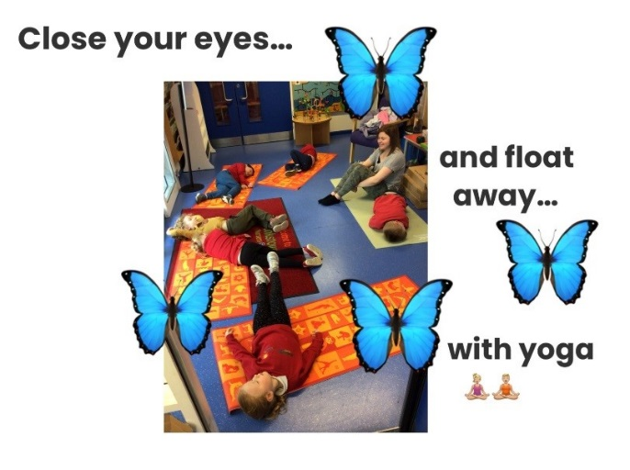

Collection Arrangements

The safety of your child is of paramount importance to us. Therefore, the following procedures have been put in place: -
- You must complete the collection form giving the names of the people most likely to be collecting your child during the year and state their relationship to the child. Names can be added throughout the year if needed.

- Unfortunately, we are not able to send a child home with anyone other than those named.

- The named persons must be over 16 years of age. (We also cannot release children to siblings who are under 16 years of age).

- It is very distressing for young children when parents arrive late. However, we do realise that on rare occasions this cannot be helped. If your child is going to be picked up late, please phone the school as soon as possible so we can prepare and reassure your child.

- Cars should be parked outside the school gates. The car park is for staff only. PLEASE DO NOT ENTER THE CAR PARK TO TURN YOUR CAR WHEN THE GATES ARE OPEN.

We are sure you understand these procedures are in your child’s best interest and hope we can work together to ensure a happy, safe and secure environment for your child.
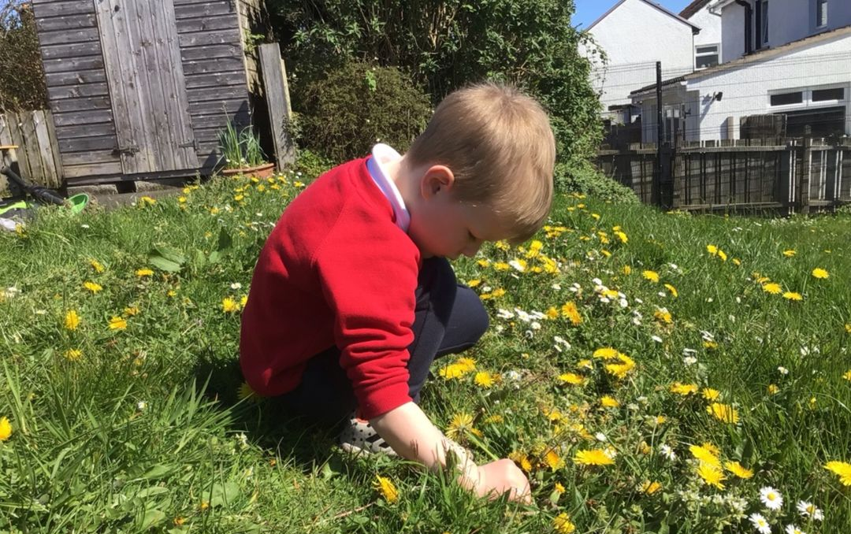

What you need to have ready for your first day

- A clearly labelled bag with a change of clothes for your child. This will remain in school and will include trousers / leggings, socks, underwear and spare shoes.

- A box of tissues for ‘runny’ noses

- A pair of wellington boots (named inside). These will stay in school.

- A special book has been provided for you to stick in photographs of people, places and events which are special to your child and we would ask that this is returned to nursery on your child’s first day. Your child can then use this special book as a source of comfort throughout the year as he/she looks at the familiar people and places. Please write captions underneath the photos as this will be a great help to the nursery team when discussing the book with your child, especially the terms for all important adults included, for example grandparents.

- Please bring in completed consent forms and contact information sheets when you come for your next visit. If you are unable to do this please make sure all forms are completed and sent in before your child starts, preferably before the end of June.

- We use the Seesaw app to communicate with you and to share photos. We will also use this to send you information and nursery newsletters so please make sure all significant adults are connected to the app. You can add more than one parent / guardian to Seesaw.

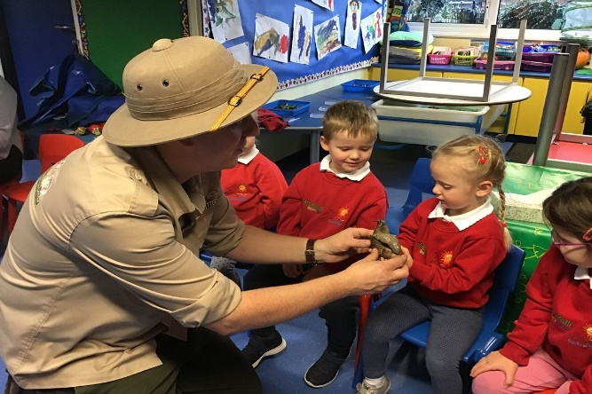

Nursery Fund

School fund will cost £4.00 (subject to change) per week. We would appreciate this being paid on a termly or half termly basis to minimise the amount of cash being collected in school. This is used: -

- to buy healthy snacks,
- to buy play dough and baking ingredients,
- to reduce the cost of school outings and visits,
- to provide gifts for the children,
- to replace broken toys and provide many resources throughout the year to enhance your child’s nursery experience,
- to provide other sundry items from which the children will benefit.

All money should be placed in a labelled envelope and given to the secretary. Her office days are Tuesday and Friday. We are unable to accept cash unless it is given to us in this way. Please make sure you have the correct amount and that you return the payment form provided.

Full Time class only - Dinners
The cost of dinners once the children start to stay will be £2.50 per day/ £12.50 paid on a weekly basis on a Tuesday morning. (Price correct at time of print).

We expect all children in the fulltime room to take school dinners. Forms will soon be available for those who wish to apply for Free School Meals. We would encourage you to fill in the forms and send them to the Education Authority, North Eastern Division as soon as possible. Unfortunately, we cannot give a child a free school meal unless we have received confirmation from the Education Authority.

Please Note: Monkstown Nursery School is a NUT FREE ZONE

Nursery Uniform

School sweatshirts will be available to purchase online at
www.signatureschools.co.uk
- or call in store: The Signature Works
Unit 5b | Castlereagh Road Business Park
Castlereagh Road | BELFAST | BT5 6BQ

- Track suit bottoms/leggings are most suitable as a nursery uniform – the children can manage much better at the toilet without belts and buttons to hamper them.

- Please remember that the children will be using paint and glue so they should not wear ‘good clothes’ in nursery. Expect your child to come home messy - this is a good sign they have been working hard and due to the often spontaneous, child-led nature of nursery we cannot guarantee aprons will always be available!
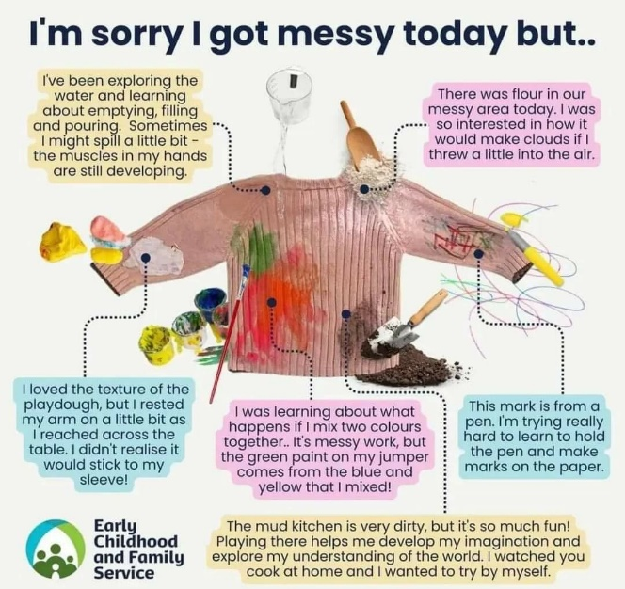

- Please make sure all clothes and shoes are clearly labelled with your child’s name.

- Please make sure your child wears sensible footwear to nursery. For safety reasons, shoes should NOT have laces and sandals should not be worn.

- Please do NOT let your child wear earrings, bracelets, necklaces or rings to nursery as they can cause harm when the children are playing and when they are putting on dressing up clothes/aprons etc. If earrings cannot be taken out then plasters must be used to cover them.
Additional Information

We would welcome a birthday cake on your child’s birthday as these are special occasions to share with our friends in nursery. Please ensure it is a nut free cake and check with your child’s teacher about any other allergies the children in the class may have.

If you move to a new house or change your phone number during the year, it is very important that you send us your updated information. We may need to contact you if there is a problem concerning your child.

We would advise against bringing toys to school for fairness for all.

We would encourage you to greet your child with a smile and not a mobile phone! Our school building and school grounds are mobile free – except in the case of an emergency. We feel it is important to be engaged with your child, especially coming to and going from school.

Throughout the year we will Seesaw information and news sheets keeping you up to date with school events. Please read these and highlight important dates in your diary.

All children will have individual and class group photographs taken during the year.

If you have ANY concerns or queries throughout the year, please do not hesitate to speak to us.
Complaints Procedure

The staff at Monkstown Nursery School are very willing to listen to any concerns you may have and will endeavour to sort out any issues, should they arise.

If you feel a more formal approach is necessary, the full Complaints Procedure Policy is available on request.

Complaints Procedure – At a glance
Stage Two
Write to the Chairperson of Board of Governors
Stage One
Write to the Principal

Child Protection

We have a responsibility towards the children in our care and each child has a fundamental right to be protected from harm. Monkstown Nursery School fully recognises its responsibilities for child protection. You will receive a copy of the Child Protection and Intimate Care Policy before your child starts nursery.

All policies are available on request.

How a parent can make known a concern

I have a concern about a/my child’s safety.

I can talk to the class teacher.

If I am still concerned, I can talk to the Designated Teacher for Child
Protection (Mrs. S. Coburn) or in her absence,
the Deputy Designated Teacher (Ms L Acheson)

If I am still concerned, I can talk/write to the Chairperson of the
Board of Governors (Ms A Bennington)
C/O Monkstown Nursery School.
At any time I can talk to the duty social worker at Gateway,
Children’s Social Work Service Tel: 03001234333 or
PSNI 02890 259299 or 101

If I am still concerned I can contact the NI Public Services Ombudsman
Tel: 0800 343 424

Positive Behaviour

Monkstown Nursery School encourages positive behaviour reinforcement at all times. This strategy aims to focus on ‘good’ behaviour instead of dwelling on the negative. Children will be rewarded for displaying positive behaviour.

We have a set of statements or “Sunshine Rules” which the children will be introduced to when they start nursery. It is important that you share and reinforce these at home to avoid confusion.

- A child may not realise that certain behaviours are unacceptable in nursery as they may be acceptable in other situations, e.g. we can run outside but it is unsafe to run in the classroom. We take time throughout the day to explain to the children why we need the sunshine rules.

- We also point out Indoors and Outdoor Rules and Rules of the Bathroom e.g. Bathroom Rules include that we flush the toilet and wash our hands afterwards.

- It is our policy that children, who display disruptive behaviour, will be channelled and directed into more constructive, challenging and meaningful play.

- The staff will consult parents in the event of any particularly serious problems arising with a specific child.

- The full Positive Behaviour Policy is available on request.

Our Sunshine Rules
We play safely and fairly.
Language we use when explaining this rule to the children:
We look after the toys.
We tidy up, brush up and pick up.
We share and take turns.
We have safe walking feet.
We are kind and helpful.
Language we use when explaining this rule to the children:
We have kind hands and use kind words
We listen to people.
We say please and thank you.
If our friend is not being kind we can say, “Please stop, I don’t like that.”
We can tell an adult if we are not happy.
We are always busy.
Language we use when explaining this rule to the children:
We try our best
We finish our activity.

Intimate Care & Toileting Expectations
It is presumed that all children will be toilet trained before coming to nursery.

Children should be independent in their toileting routine (pulling down and putting on clothing, wiping their bottom, washing their hands etc) and require very little assistance.

If a child has a toileting accident the Nursery Child Protection Policy Guidelines will be followed.

Should toileting accidents become a regular occurrence the staff will discuss with the parent the most suitable approach to take. You will receive a copy of the school’s Intimate Care Policy outlining these procedures in more detail.

If a child has a statement of educational needs, the nursery staff will determine the most suitable approach to toileting on an individual basis.

It is very important you ensure a change of clothes is always available in nursery.

If we have had to change your child, we will send a record of the change home with the soiled clothes.

Health and Safety
You will have beeen asked to complete a form giving a brief outline of your child’s medical history so that we are aware of any problems such as allergies, speech or hearing problems. Please send this in as soon as possible.

- Children, who are unwell, have a temperature, or sickness, or who have an infectious disease should remain at home. If your child is unwell through the night or in the morning before nursery we would ask that you do not send your child into school. Bugs spread very easily amongst young children as we are sure you are aware.

- If a child has suffered from any diarrhoea and/or vomiting, they must not attend the nursery until they have been symptom-free for at least 48 hours.

- If a child becomes ill during a session, every attempt will be made to contact one of the people listed on the registration form, to arrange collection of the sick child.

- If a child has a communicable disease, they should not attend the nursery until they are no longer infectious.

- If your child has taken medicine in the morning, please pass this information to the nursery staff.

- In the event of your child requiring prescribed medication in school you will be asked to complete a form giving staff permission to administer such medications, for example, inhalers.

- Any accidents that occur in nursery will be recorded on an Accident Form. A record slip will be given to you at collection time.

- In the event of a more serious accident or any kind of head injury, you will be contacted immediately.

- If your child has had chicken pox, the heath guidelines state it is recommended that your child returns to nursery no earlier than 5 days after the rash has fully developed (e.g. 5 days from the appearance of the last spot).
Please contact us if you would like any further information
Principal and Full Time Room Teacher: Mrs S Coburn

Part Time Room Teacher: Ms L Acheson

Nursery Assistants: Mrs E Owen, Mrs H McCarey
Mrs H Crowe, Mrs M Jones

Chairperson of the Board of Governors: Ms A Bennington
Caretaker: Mrs E Ferguson
Secretary: Mrs C Smolenska

Address: Jennings Park,
Monkstown
Newtownabbey
BT37 0NB

Telephone: 028 90861459

Email:
info@monkstownns.monkstown.ni.sch.uk

Have a look at our website:
http://www.monkstownnurseryschool.co.uk

Full-time Session: 9.00am-1.30pm
Morning Session: 8:45-11.15am
Afternoon Session: 12.30pm-3.00pm

  - HOLIDAY LIST 2023/24

Autumn Term
Bank Holiday: Monday 28 August 2023 (school closed)
School commences: Tuesday 29 August 2023 (selected children will attend the previous week)
Half-Term: Monday 30 October - Friday 3 November 2023
School finishes: Thursday 21 December 2023 (early finish)

Spring Term
School commences: Monday 8 January 2024
Half-Term: Monday 12 February- Friday 16 February 2024
School finishes: Friday 22 March 2024 (early finish)

Summer Term
School commences: Monday 8 April 2024
May Day Holidays: Monday 6 May - Tuesday 7 May 2024
Spring Bank Holiday: Friday 24 May - Monday 27 May 2024
School finishes: Tuesday 25 June 2024

